Practice Activity: Create a Resume in Microsoft Word

Before You Begin
✅ Download all attached files.
✅ Save the files in your Office Fund folder before starting.

Purpose
In this activity, you will create a resume for a graphic designer in New Brunswick.
You will practice:

- Adding text
- Formatting text
- Creating tables
- Modifying tables
- Creating a footer
- Saving and organizing files

Step 1: Open and Save Your Document
- Open Microsoft Word.
- Select Blank Document.
- Select File > Save As.
- Click Browse.
- Open your Office Fund folder.
- Save your file as: FirstnameL_Word2
Example: AynslieC_Word2

Step 2: Turn On Helpful Tools
Show Formatting Marks
- Select the Home tab.
- In the Paragraph group, click the Show/Hide (¶) button.
Tip: This is a toggle button.
- Click once = ON
- Click again = OFF
Show the Ruler
- Select the View tab.
- In the Show group, check the Ruler box.

Step 3: Add a Footer
- Select the Insert tab
- In the Header & Footer group
- Select the ▼ under Footer
- Select Edit Footer.
Insert the File Name
- In the Inset group
- Select the ▼ under Document Info
- Select File Name field.
⚠️ Do not type the file name manually. Use the Document Info feature.

Step 4: Creating a Table
- Select the Insert tab
- In the Tables group
- Select the ▼ under Table
- Drag your cursor in the grid to create a table with
- 2 columns
- 4 rows

Step 5: Adding Text
- Open the file Word_Practice2_Copy
- Select: PROFESSIONAL OBJECTIVE
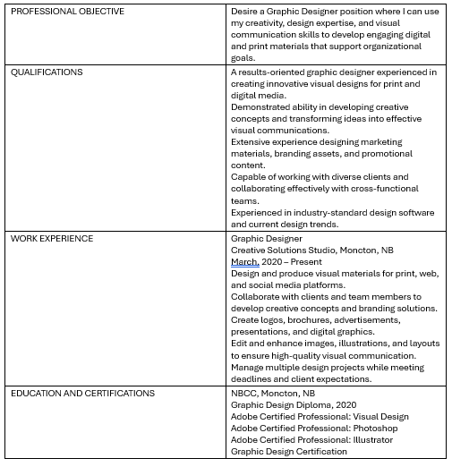
- Copy the text by using Ctrl-X (CMD-X for Mac users)
- Move to the Word document and place the cursor in the first cell
- Paste the text by using Press Ctrl-V (CMD-V for Mac users)
- Remove the blank line at the end of the pasted text (if necessary)
- Return to the Word_Practice2_Copy file
- Copy and paste until your table looks like this

Step 6: Apply Bullets
- Select the text to the right of the QUALIFICATIONS column
- Select the Home tab
- In the Paragraph group
- Click the Bullets icon
- Ensure the text is still selected
- Drag the Left Indent handle to the left to reduce the indent

Apply the Same Format
- Select the text to the right of the QUALIFICATIONS column
- Select the Home tab
- In the Clipboard group
- Double-Click the Format Painter icon
- Drag the cursor over all the text in the right column of WORK EXPERIENCE and EDUCATION AND CERTIFICATIONS
- Click the Format Painter icon once to toggle off

Step 7: Adjust Column Size
- Hover the mouse over the middle vertical border until the cursor looks like a double vertical line with arrows
- Click and drag until the white arrow on the ruler is approximately 1.5 inches on the horizontal ruler.

Adjust Column to Exact Specifications
- Click anywhere in the left column
- Select the Table Layout tab
- In the Cell Size group
- Set the Width to 1.4”

Adjust Column to Fit the Window
- Select the entire table
- Select the Table Layout tab
- In the Cell Size group
- Select the ▼ under AutoFit
- Click AutoFit Window

Check to see whether your document looks like this:
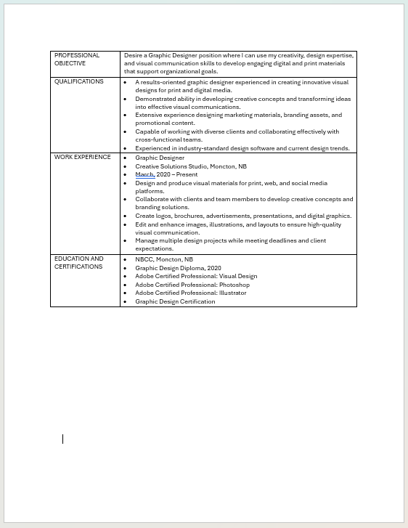

Step 8: Insert a Row within the Table
- Hover near the left border above EDUCATION AND CERTIFICATIONS
- Click the Plus Sign when it appears
- Open the file Word_Practice2_Copy
- Select: TECHNICAL SKILLS
- Copy the text by using Ctrl-X (CMD-X for Mac users)
- Move to the Word document and place the cursor in the first column
- Paste the text by using Press Ctrl-V (CMD-V for Mac users)
- Remove the blank line at the end of the pasted text (if necessary)
- Return to the Word_Practice2_Copy file
- Copy and paste the block of text starting with “Platforms: Windows 10, macOS”

Apply Formatting
- Select the text to the right of the QUALIFICATIONS column
- Select the Home tab
- In the Clipboard group
- Double-Click the Format Painter icon
- Drag the cursor over all the text in the right column of TECHNICAL SKILLS
- Click the Format Painter icon once to toggle off

Step 9: Adjusting Table Cell Margins
- Select the Table Layout tab
- In the Alignment group
- Select Cell Margins
- Adjust the Top and Bottom Cell Margins to 0.04”
- Click OK

Step 10: Insert a Top Row
- Select the Table Layout tab
- In the Rows & Columns group
- Select Insert Row Above

Merging Cells
- Select the top row
- Select the Table Layout tab
- In the Merge group
- Click Merge Cells

Adding Text
- Open the file Word_Practice2_Copy
- Copy and paste the block of text starting with “Matt Smith”
- Move to the Word document and place the cursor in the first row
- Paste the text by using Press Ctrl-V (CMD-V for Mac users)
- Remove the blank line at the end of the pasted text (if necessary)
- Replace the name and email address with your name and email address

Formatting the Text
- Select your name
- Use the mini-toolbar to
  - Bold
  - Italic
  - Change Font Size to 14
- Select all the text in the top row
- Select the Home tab
- Expand the Paragraph group
- In the Spacing section
- Change the Before and After to 0pt
- Click Ok
- In the Paragraph group
- Click Center Alignment

Step 11: Format Remaining Text
- Select all the Headings in the first column (all below the address row)
- Select the Home tab
- In the Font group
- Click on Bold and Italic
- Apply the same formatting to
  - Graphic Designer (in WORK EXPERIENCE)
  - NBCC, Moncton, NB (in EDUCATION AND CERTIFICATIONS)

Adding Space Between Lines
- Place the cursor at the line beginning with “Graphic Design Diploma” (in EDUCATION AND CERTIFICATIONS)
- Select the Home tab
- Expand the Paragraph group
- In the Spacing section
- Change the After to 12pt
- If necessary, deselect the Don't add space between paragraphs of the same style box.
- Apply the same formatting to
  - “Graphic Designer” (in WORK EXPERIENCE)
  - Your name (In top row)

Step 12: Formatting the Table Borders
- Select the entire table by using one of the following three methods
  - Click the cross indicator in the upper left-hand corner of the table, or
  - Start at the top of the table and Click and Drag to select the entire table, or
  - Use the Shortcut Key CTRL + A (CMD+A for Mac Users)
- Select the Table Design tab
- In the Borders group
- Click the ▼ under Borders
- Select No Borders
- Select table
- Click the ▼ under Borders again
- Select Borders and Shading
- On the Borders tab
- In the Style group
- Select the thick upper line and thin lower line (ninth on list)
- In the Preview group
- Deselect the left and right borders. If necessary, deselect inner borders
- See image below
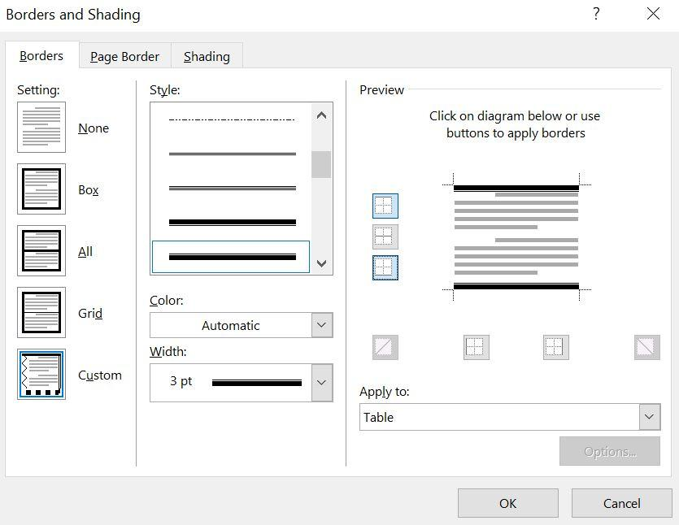

Step 14: Final Check
- Turn off formatting marks.
- Compare your resume with the example provided by your instructor (Scroll down).
- Make any corrections needed.
- Use Zoom (bottom-right corner of Word) to view your work more clearly.
- Save your document again.
- Upload your completed Word document to the correct assignment folder in Brightspace.

